

X



**PREDICTIVE ANALYSIS PROJECT**

**Presentation**

PERSONALIZED PRODUCT RECOMMENDATION SYSTEM WITH SENTIMENTAL ANALYSIS

|  |  |  |
| --- | --- | --- |
| NATANSH SHARMA | R2142220115 | 500104474 |
| PIYUSH SINGLA | R2142220893 | 500107861 |

**Abstract**

* In today's digital marketplace, personalized product recommendation systems play a pivotal role in enhancing user experience and driving sales. This project presents a comprehensive approach to developing a personalized product recommendation system that integrates sentiment analysis to refine and optimize product suggestions. By leveraging user behaviour data and analysing sentiment from customer reviews, our system aims to deliver tailored recommendations that resonate with individual user preferences.
* The methodology involves a hybrid approach that combines content-based and collaborative filtering techniques to enhance recommendation accuracy. Additionally, sentiment analysis is employed to evaluate the emotional tone of user feedback, allowing the system to prioritize products with positive sentiments while filtering out those that may not meet user expectations. The implementation utilizes Python and popular libraries such as Scikit-learn and NLTK for machine learning and natural language processing tasks.
* This project not only addresses the challenges inherent in recommendation systems, such as the cold start problem and data sparsity but also lays the groundwork for future enhancements, including the incorporation of additional data sources and advanced deep learning techniques. Ultimately, our personalized product recommendation system aims to revolutionize the way users discover products, fostering a more intuitive and engaging shopping experience. convert this into summarized bullet points

# Objectives

* Create a system that tailors product suggestions based on individual user preferences and behaviours.
* Analyse customer reviews to gauge emotional sentiments and incorporate this data into the recommendation process.
* Filter product suggestions to highlight those with favourable user feedback, thereby increasing the likelihood of user satisfaction.
* Establish a foundation for future enhancements, including the integration of additional data sources and the application of advanced deep learning methods.
* Aim to increase user satisfaction and engagement through more relevant and personalized product recommendations.

# Methodology

A personalized product recommendation system with sentimental analysis typically involves a multi-step approach. First, a user-user or item-item collaborative filtering method is used to build the recommendation system. Then, sentiment analysis is integrated into the system using techniques such as logistic regression, machine learning algorithms, or natural language processing.

**Step 1: Building the Recommendation System**

* Use a user-user or item-item collaborative filtering method to build the recommendation system
* Collect user-product rating data and use it to train the model
* Use algorithms such as User-User -based recommendation algorithm for product recommendations
* Calculate the similarity between users based on their past behaviour and preferences

**Step 2: Integrating Sentiment Analysis**

* Collect product review data and use it to train a sentiment analysis model
* Use techniques such as logistic regression, machine learning algorithms, or natural language processing to analyse the sentiment of the reviews
* Assign a weight to each word in the review using TF-IDF (Term Frequency-Inverse Document Frequency)
* Use the sentiment analysis model to predict the sentiment of new reviews

**Step 3: Combining Recommendation System and Sentiment Analysis**

* Use the output of the recommendation system and sentiment analysis model to generate a ranking score for each product
* Use a formula such as (W1*predicted rating of recommended product + W2*normalized sentiment score on scale of 1–5 of recommended product) to calculate the ranking score
* Use the ranking score to rank and sort product recommendations or filter them out depending on the number of recommendations we want to show

**IMPLEMENTATION**

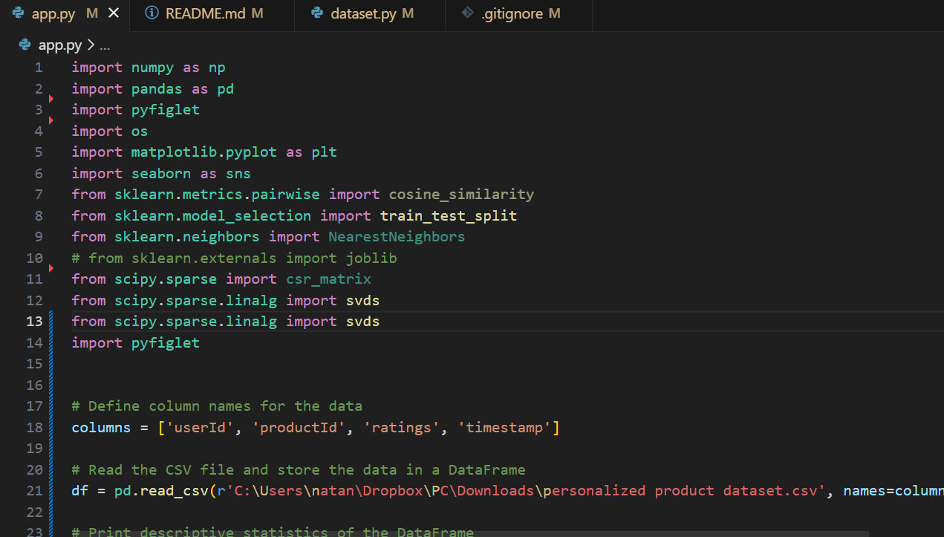

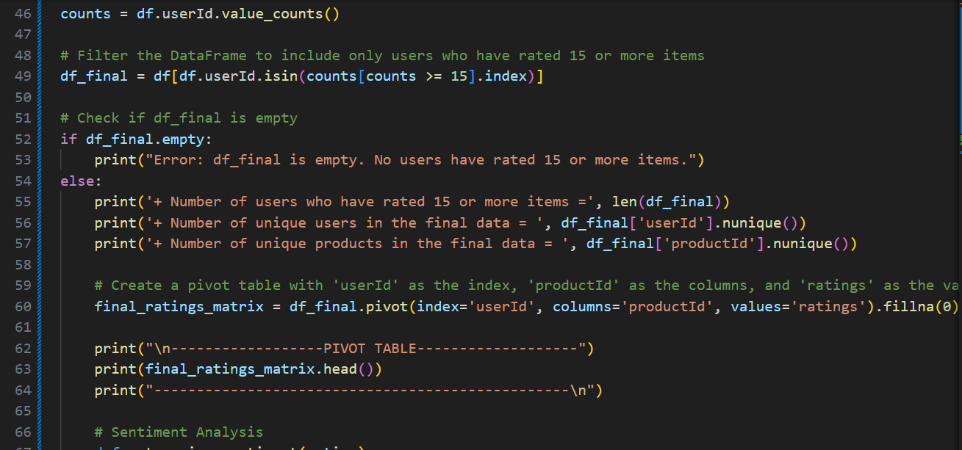

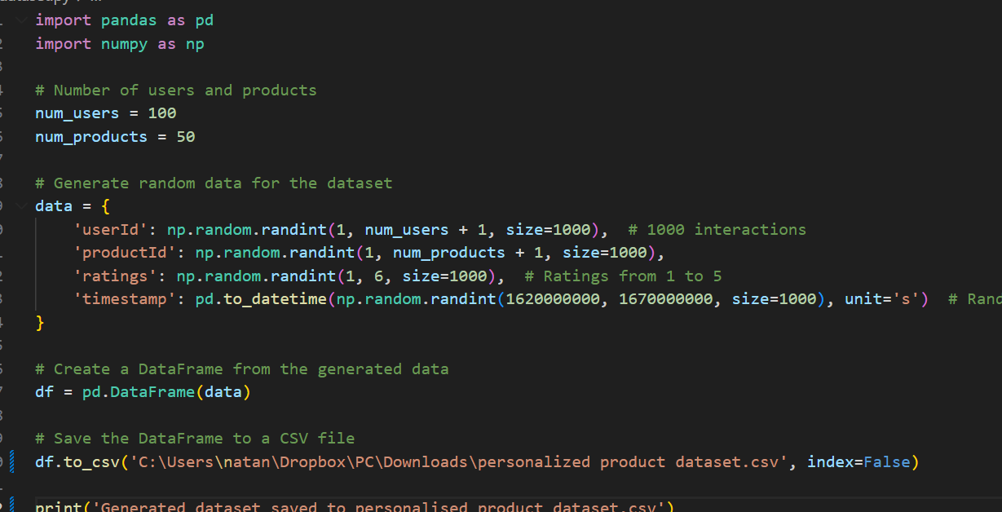

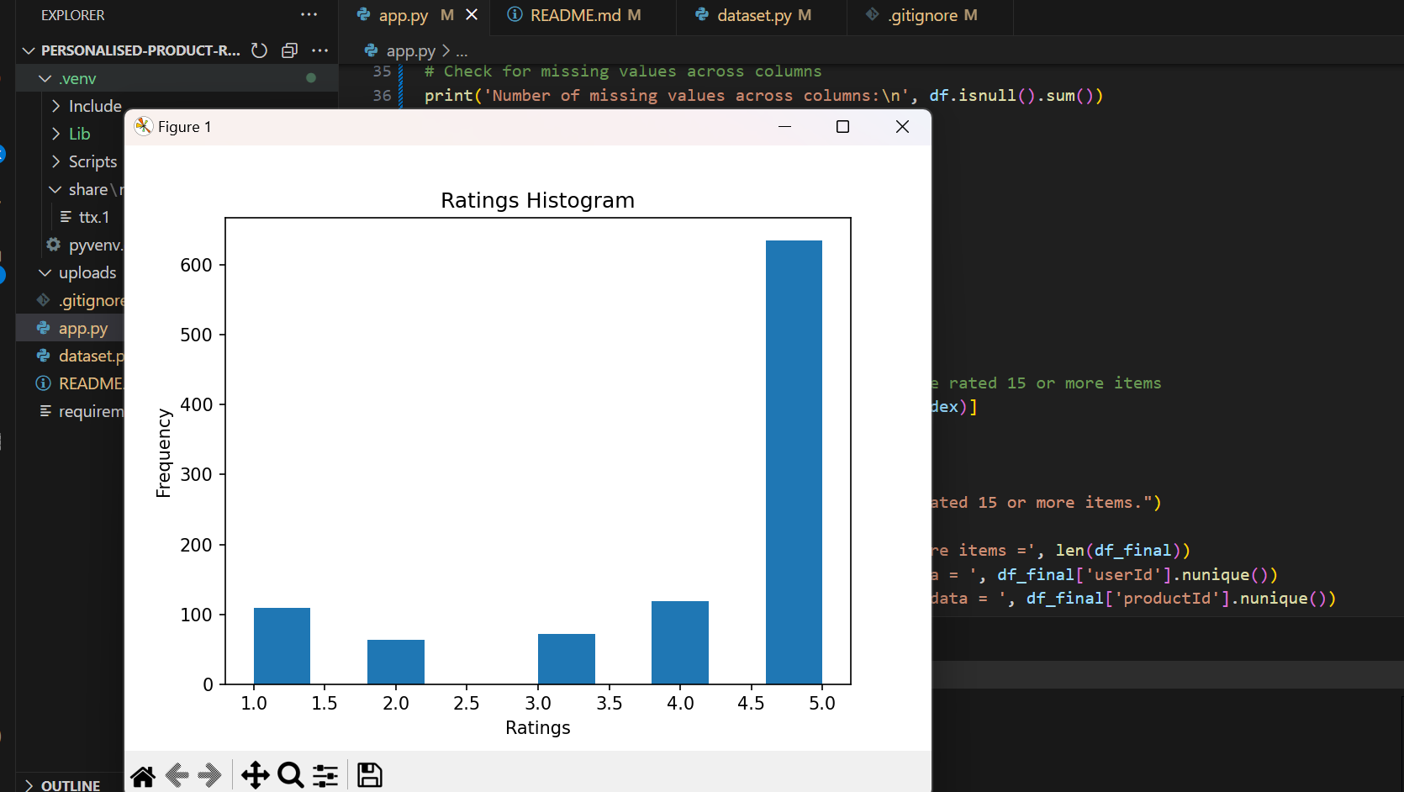

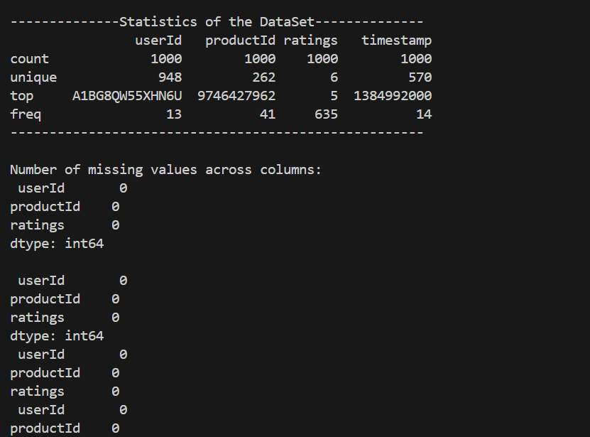

# Tools and Technologies

* PYTHON
* NUMPY
* PANDAS
* VENVE ENVIRONMENT

**PERT Chart (Aug-Dec)**

